Quiz Game in CPP – Project Introduction:

I have divided this mini project into many functions, and listed below are some of those which may help you understand the project better.

* edit_score() – adds the current cash prize won to the previous one upon giving the right answer to a question
* help() – help menu with game summary and rules
* reset_score() – to reset the highest score/cash prize to default
* show_record() – shows the highest cash prize won by a particular user
* show_score() – to view the highest score

In this quiz game mini project, you can store the user name, view the highest score secured by a user, and even reset the score. Additionally, to make the game look a little more interesting, it is divided into two rounds; user must pass the first round to reach the second one.

Of the 2 rounds I mentioned above, the first is called the Warm-up Round; the second is the Challenge round. In the warm-up round, the user is asked a total of three simple questions and they must be able to answer at least two of them correctly to enter the next round. If the user is not capable of doing that, he is not permitted to proceed further.

In the second and more interesting round of this quiz game in CPP, the user will be asked questions continuously, and for each right answer given, they will earn $100,000!

The game ends when the user’s cash prize piles up to $1 million. For each question asked, there are 4 options, namely A, B, CPP and D. There are no negative markings, so the user’s accumulated cash money won’t be deducted for wrong answers to the questions.

Output Screenshots:

[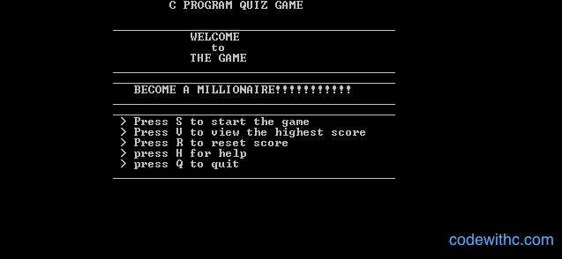](https://www.codewithc.com/wp-content/uploads/2014/03/welcome-screen.png)Welcome Screen[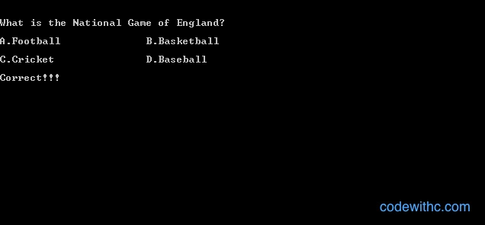](https://www.codewithc.com/wp-content/uploads/2014/03/correct-answer.png)Correct Answer[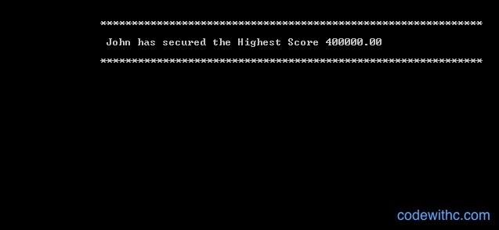](https://www.codewithc.com/wp-content/uploads/2014/03/view-highest-score.png)Highest Score